>https://material.angular.io/components/categories

-->Javascript feautes(aka pain-points)

https://5c54aa429e16c80007af3cd2--reactjs.netlify.com/tutorial/tutorial.html

1)protoypcal inhetence

2)function programming

3)lexical scopting

4)closure.

5)’this’ – context

6) Methode Borrowing.

-bind

-call ,-apply

7)WEB RESOURCES

1.mdn – developer.mozilla.org

Books

1.javascipt-the definiteive guide

2.javascript- the good parts.

#https://babeljs.io/

--->jsx--->esx

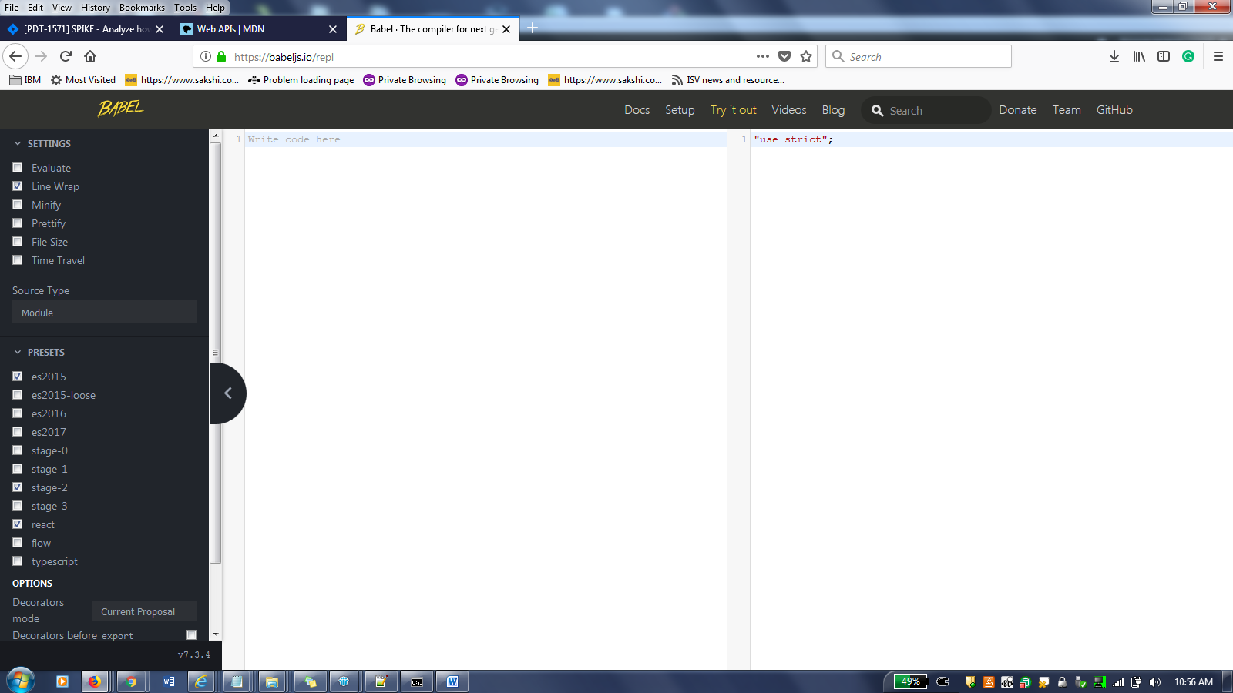

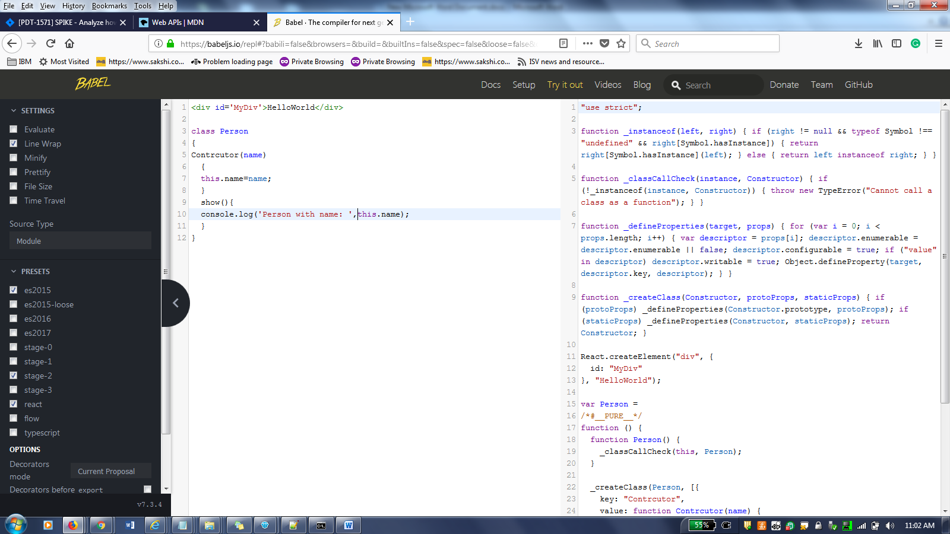

**code.visualstudio.com**

visual studio: text editor for javascipt

>node js:

NodeVersionManager (NVM)

(nvm 10.15.3)

-------------------------->

<https://cli.angular.io>

x=99

>y=89

Window.x

>

Window.x

>window within the same name space(code always)

<https://www.npmjs.com/>

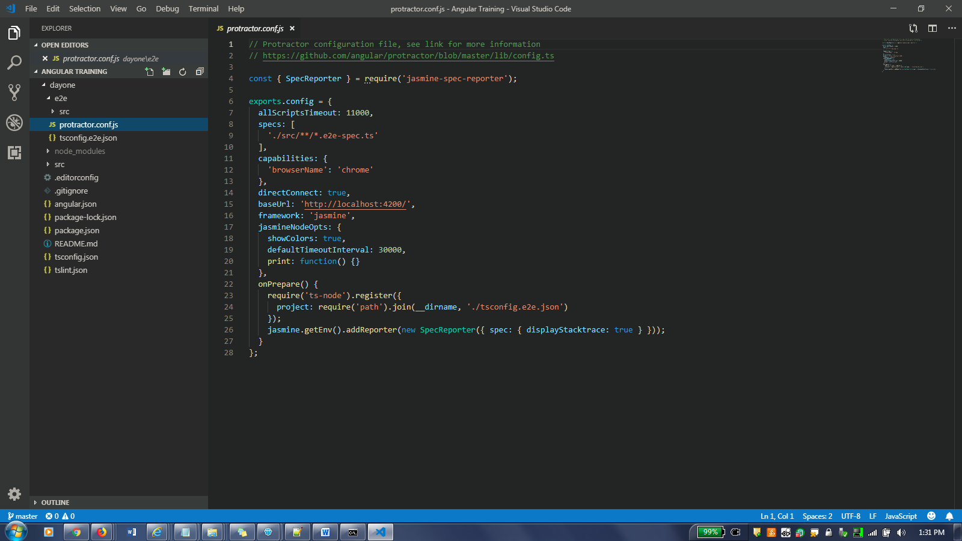

>ng new dayone

Rouing-n

css

>:

https://angular.io/tutorial

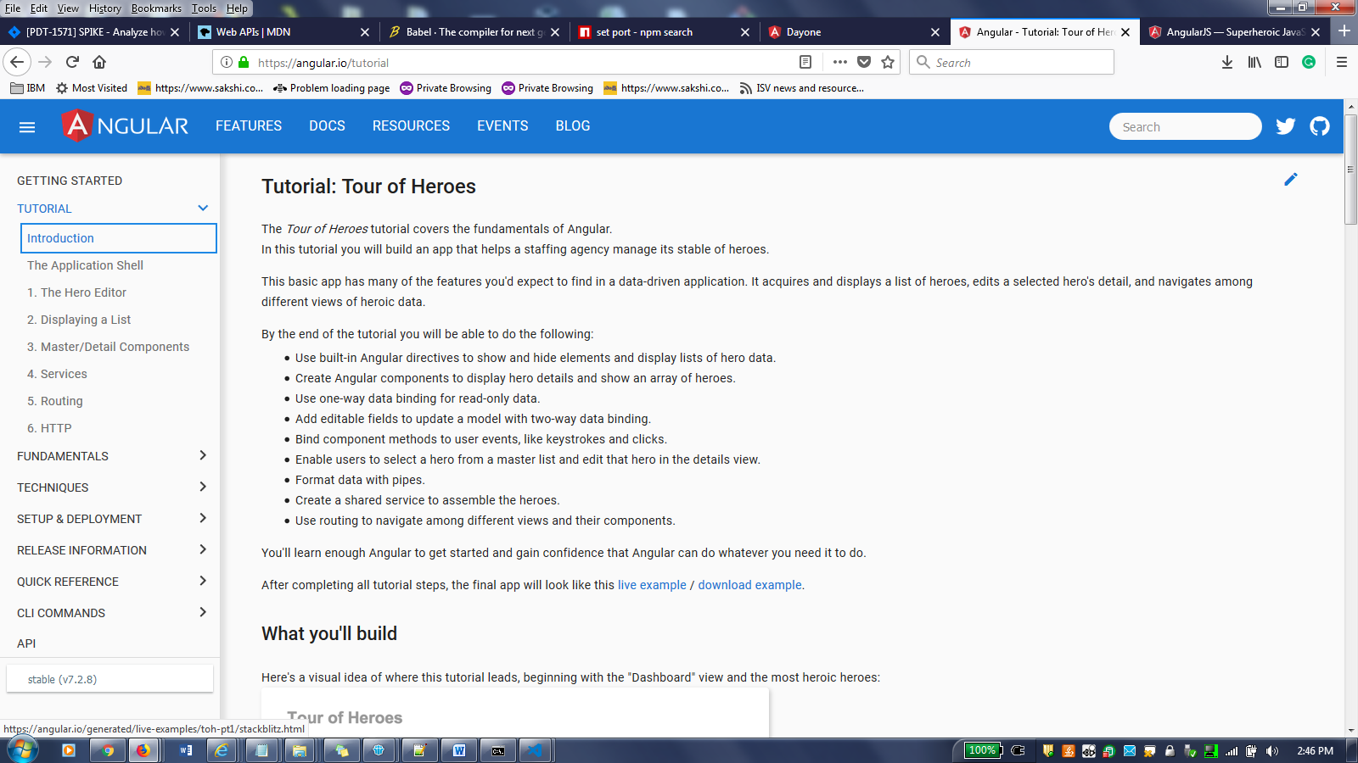

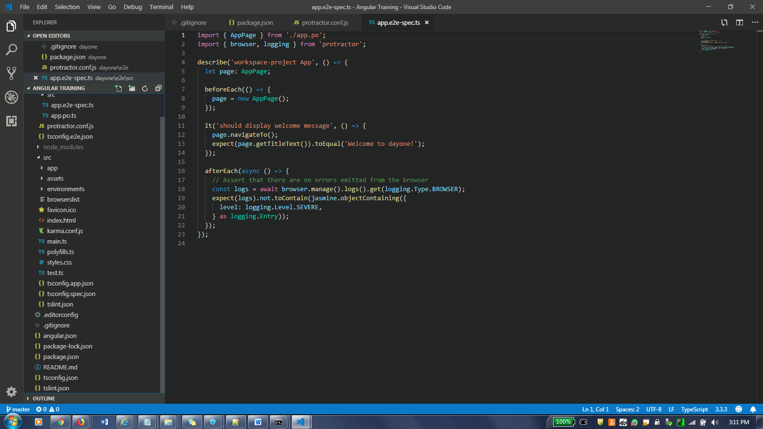

Main.ts

//execution beings

Karma.conf.js :testing

Poliyfilles.js fetch the values which are not inhereitece

Index.html : where we can show the defacult ocnetnt.

<app-root></app-root>

Application pages never indexed, it will show the empty html pages.

Polyfills.js // inhernce

Hybried desing;

Main.js //render

App.moduel.ts:

Spect. File/testing

App.compoent.ts----root component

App.compoent.html—html file render

App.compoient.css--css

App.component.ts—

@compoent({ selector : ‘app-root’, templateUrl:’./app.component.html’, styleurls: [‘./app.component.css’] })

Media query/usergetns –find the diff browrs

Demo.html:

<div id=”myDiv”>

</div>

Demo.css:

#myDiv

{

Border:2px solid red;

Margin:5px;

Padding:5px;

}

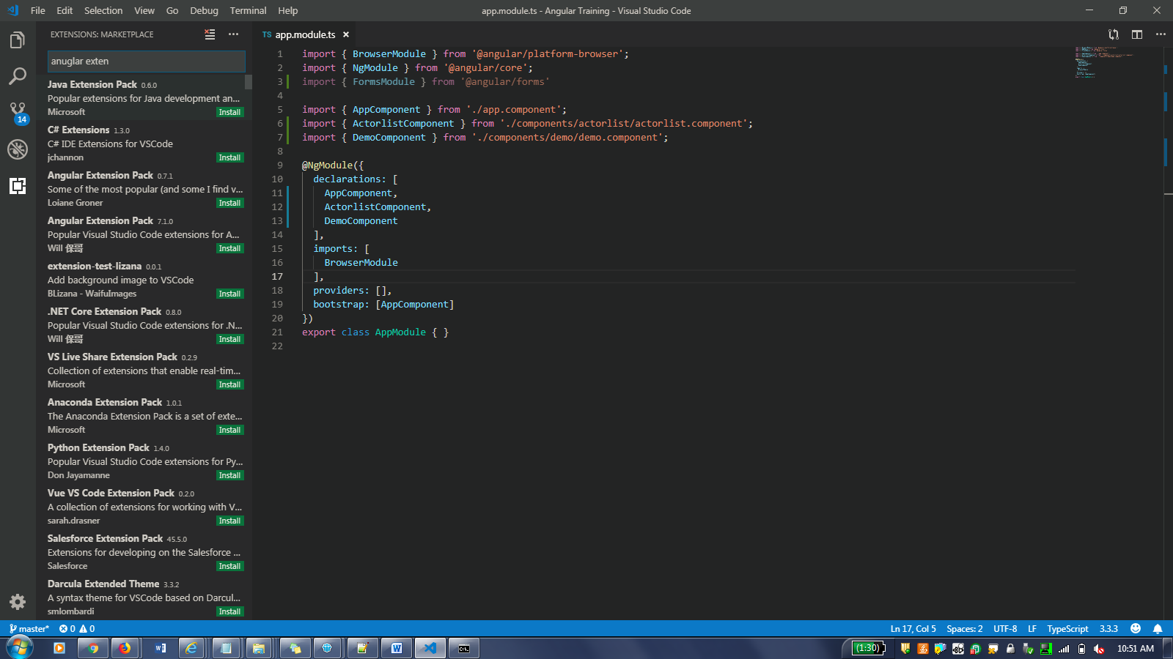

Angualr 2.0: shadown dom

Remove the element from the dom tree.